**Aim: Image Recognition with AWS Rekognition, Lambda, and IAM.**

1. Go to IAM Console:

- In the AWS Management Console, navigate to [IAM](https://console.aws.amazon.com/iam/).

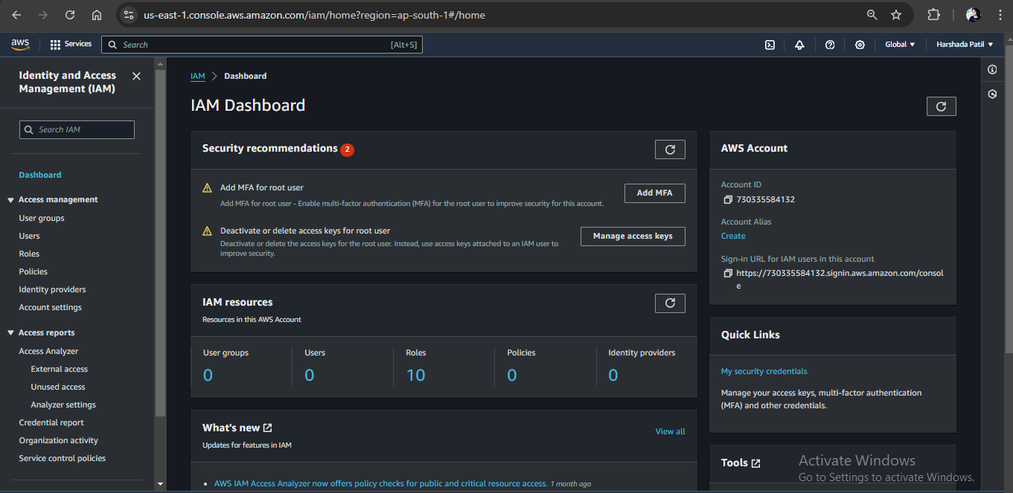

2. Create a Role:

- Click on "Roles" and then "Create role."

- Select "AWS Service" and choose "Lambda" as the service that will use this role.

- Click "Next: Permissions."

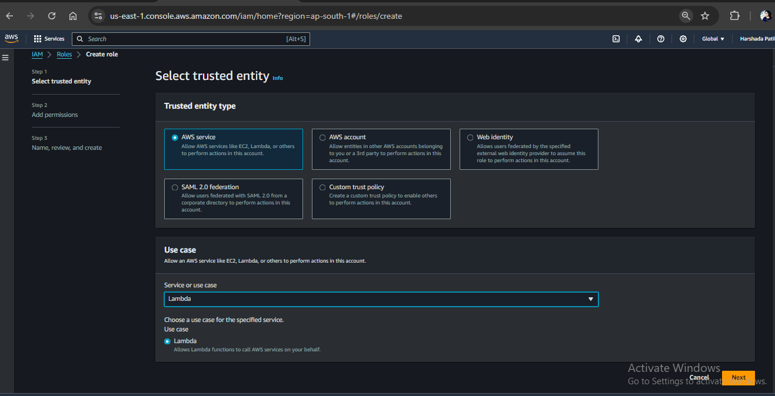

3. Attach Policies to the Role:

- Attach the `AmazonRekognitionFullAccess` policy to allow access to Rekognition services.

- Attach the `AmazonS3FullAccess` policy to allow access to S3.

- Click "Next: Tags," add any tags if necessary, and then click "Next: Review."

- Provide a role name (e.g., `LambdaRekognitionRole`) and create the role.

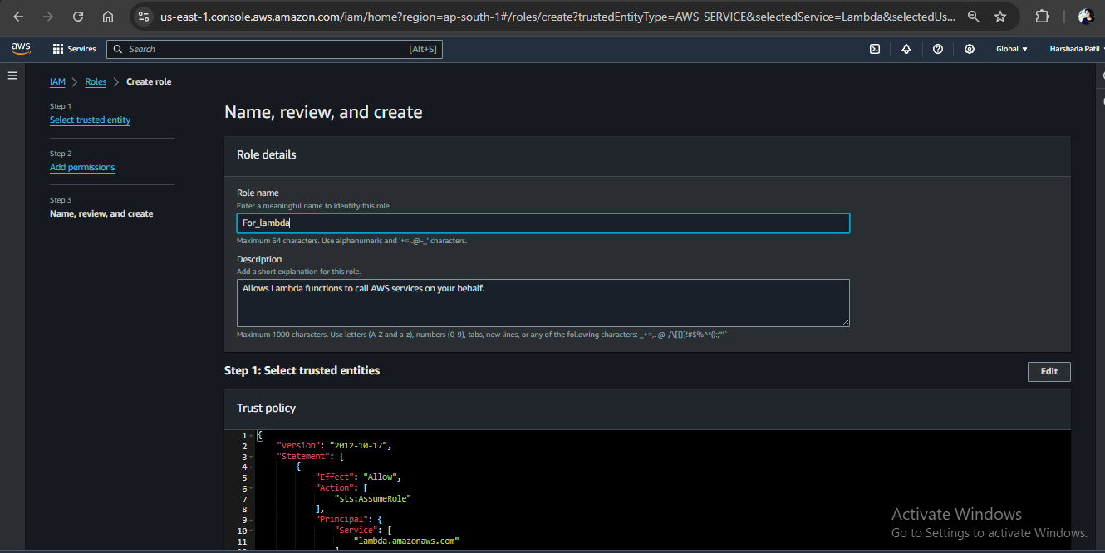

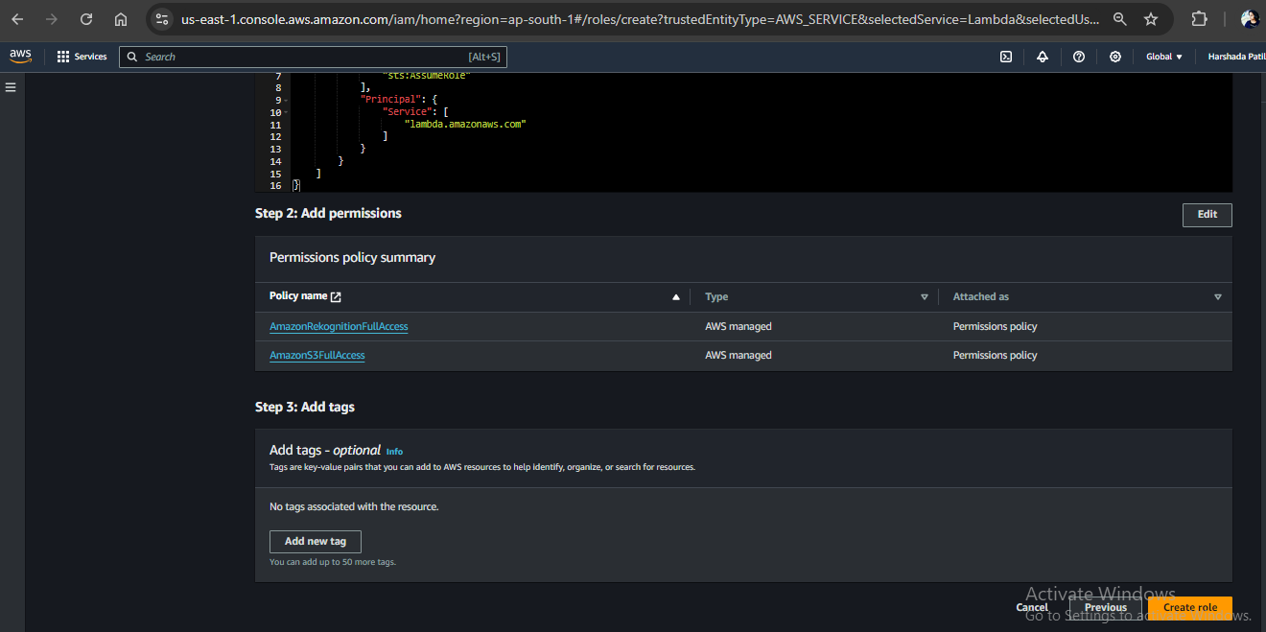

1. Go to S3 Console:

- Navigate to [S3](<https://console.aws.amazon.com/s3/>).

1. Create Input Bucket:

- Click "Create bucket."

- Enter a unique bucket name (e.g., `input-bucket-name`).

- Choose a region and click "Create bucket."

1. Create Output Bucket:

- Click "Create bucket."

- Enter a unique bucket name (e.g., `output-bucket-name`).

- Choose a region and click "Create bucket."

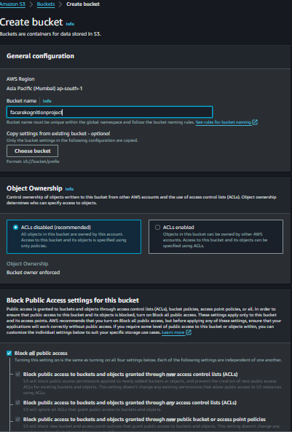

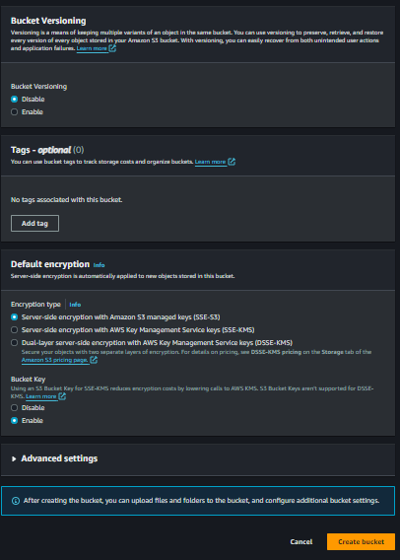

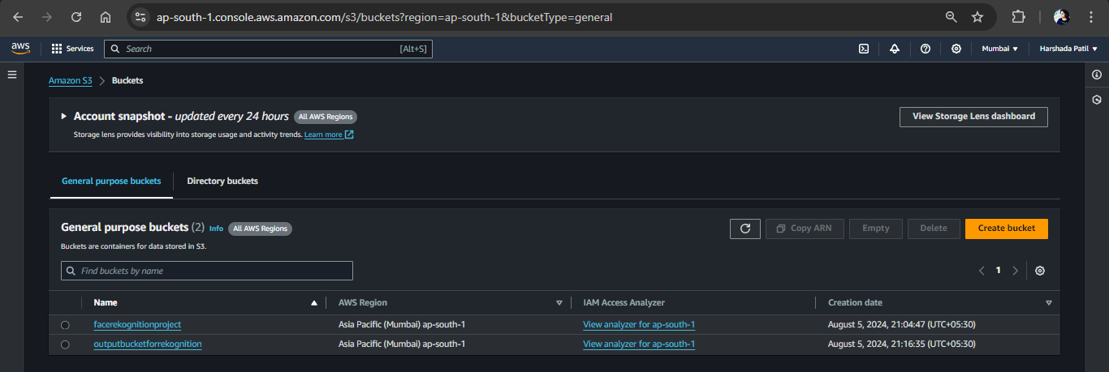

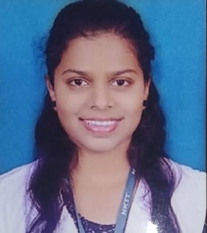

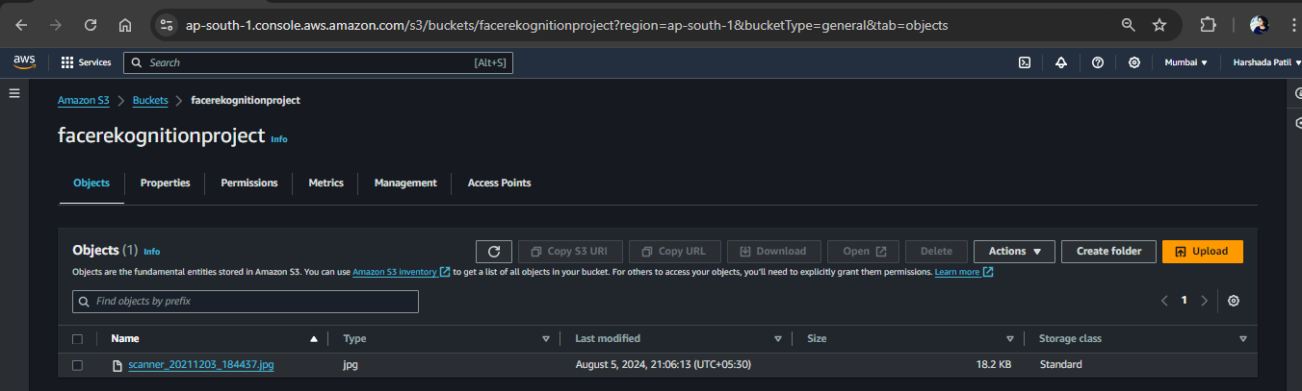

1. Go to Lambda Console:

- Navigate to [Lambda](https://console.aws.amazon.com/lambda/).

1. Create a New Function:

- Click "Create function."

- Choose "Author from scratch."

- Provide a function name (e.g., `RekognitionImageProcessor`).

- Select "Python 3.12" as the runtime.

- Under "Permissions," choose "Use an existing role" and select the role you created (`LambdaRekognitionRole`).

- Click "Create function."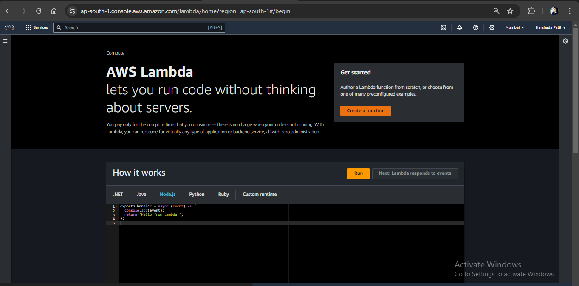

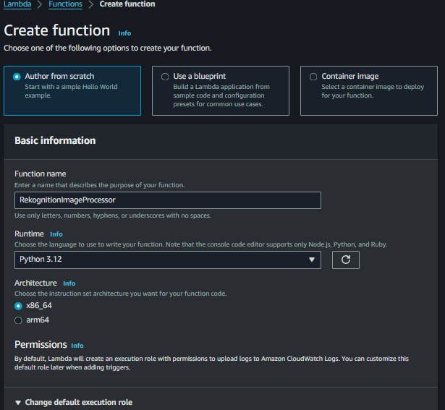

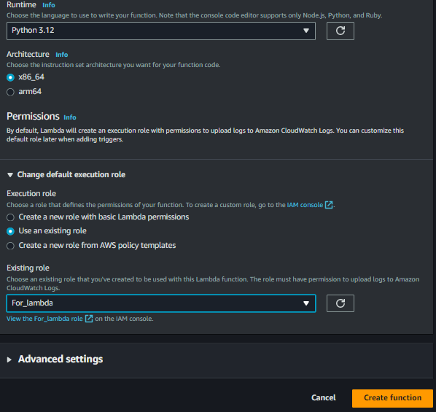

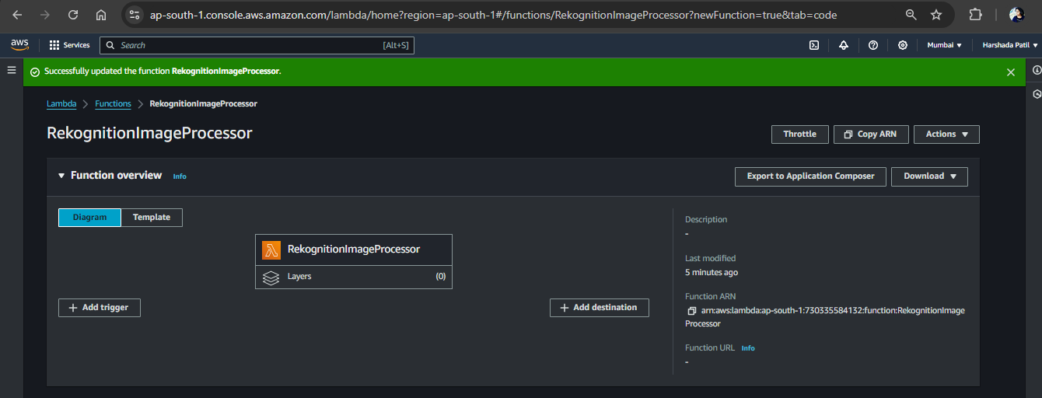

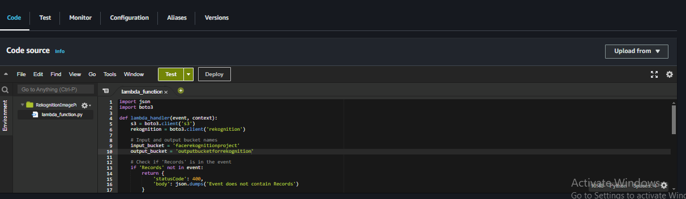

import json

import boto3

def lambda_handler(event, context):

s3 = boto3.client('s3')

rekognition = boto3.client('rekognition')

# Input and output bucket names

input_bucket = 'facerekognitionproject'

output_bucket = 'outputbucketforrekognition'

# Check if 'Records' is in the event

if 'Records' not in event:

return {

'statusCode': 400,

'body': json.dumps('Event does not contain Records')

}

# Process each record in the event

for record in event['Records']:

key = record['s3']['object']['key']

try:

# Call Rekognition

response = rekognition.detect_labels(

Image={'S3Object': {'Bucket': input_bucket, 'Name': key}},

MaxLabels=10

)

# Save the response to the output bucket

output_key = key.replace('.', '_') + '_labels.json'

s3.put_object(

Bucket=output_bucket,

Key=output_key,

Body=json.dumps(response['Labels'])

)

except Exception as e:

print(f"Error processing {key}: {str(e)}")

return {

'statusCode': 500,

'body': json.dumps(f"Error processing {key}: {str(e)}")

}

return {

'statusCode': 200,

'body': json.dumps('Image processed successfully')

}

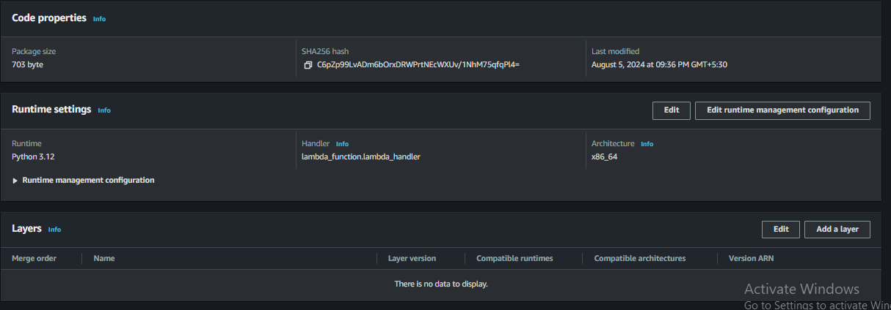

1. Navigate to S3 Bucket:

- Go to the S3 console and select the input bucket.

1. Set Up Event Notification:

- Click on the "Properties" tab.

- Scroll down to "Event notifications" and click "Create event notification."

- Configure the event to trigger on `PUT` events for new objects.

- Choose to send the event to the Lambda function you created.

- Save the configuration.

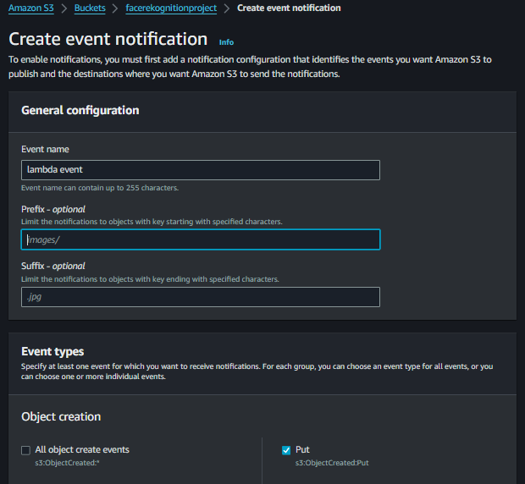

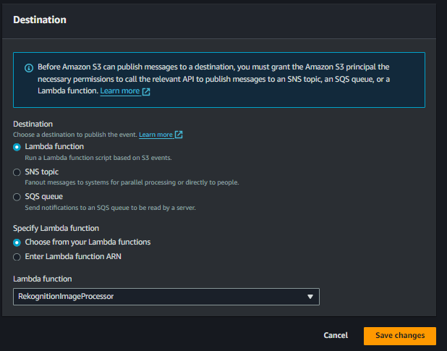

1. Create Test Event**:

- In the Lambda console, go to the "Test" tab.

- Click "Configure test events."

- Create a new test event with the following JSON format: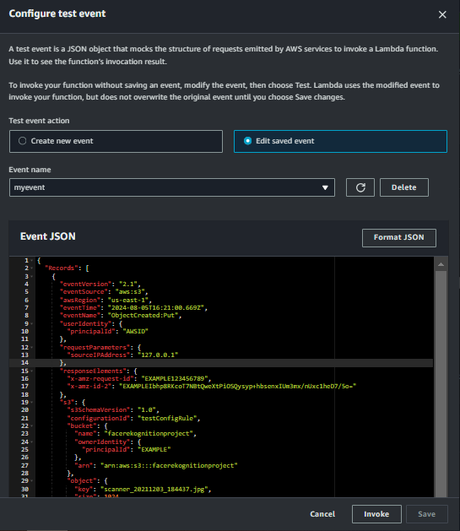

{

"Records": [

{

"eventVersion": "2.1",

"eventSource": "aws:s3",

"awsRegion": "us-east-1",

"eventTime": "2024-08-05T16:21:00.669Z",

"eventName": "ObjectCreated:Put",

"userIdentity": {

"principalId": "AWSID"

},

"requestParameters": {

"sourceIPAddress": "127.0.0.1"

},

"responseElements": {

"x-amz-request-id": "EXAMPLE123456789",

"x-amz-id-2": "EXAMPLEIbhp8RKcoT7NBtQweXtPiOSQysyp+hbsenxIUm3mx/nUxc1heD7/5o="

},

"s3": {

"s3SchemaVersion": "1.0",

"configurationId": "testConfigRule",

"bucket": {

"name": "facerekognitionproject",

"ownerIdentity": {

"principalId": "EXAMPLE"

},

"arn": "arn:aws:s3:::facerekognitionproject"

},

"object": {

"key": "scanner_20211203_184437.jpg",

"size": 1024,

"eTag": "0123456789abcdef0123456789abcdef",

"sequencer": "0A1B2C3D4E5F678901"

}

}

}

]

}

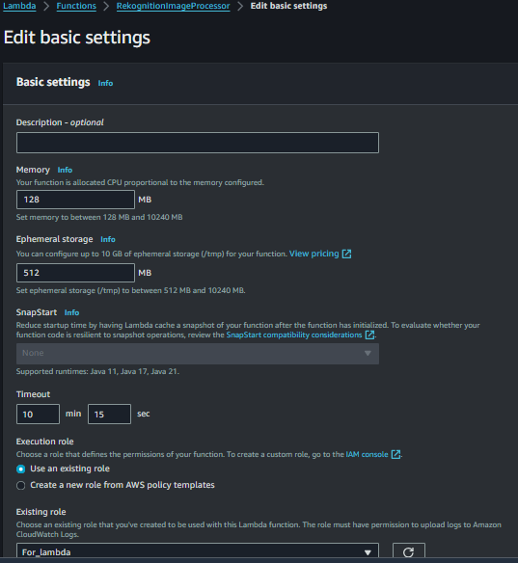

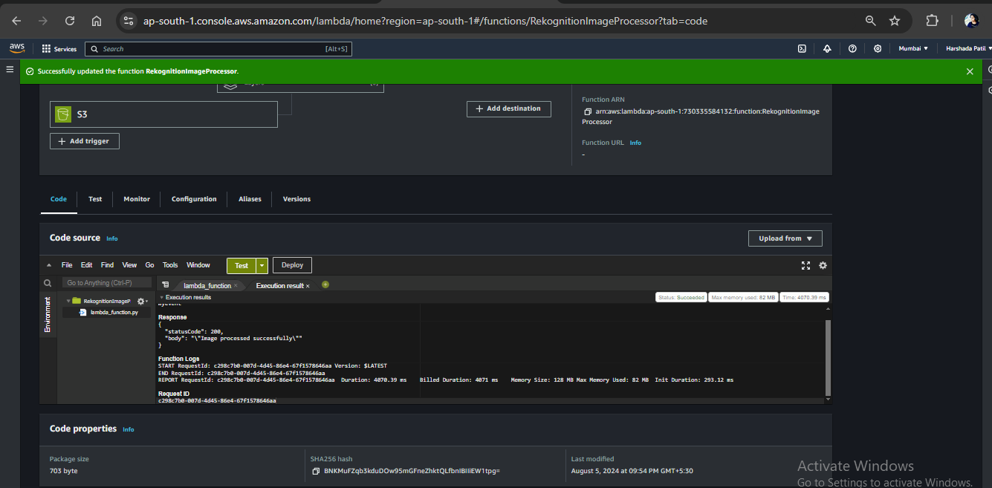

1. Go to Output S3 Bucket**:

- Navigate to the output S3 bucket and verify that the JSON file with the Rekognition labels has been created.

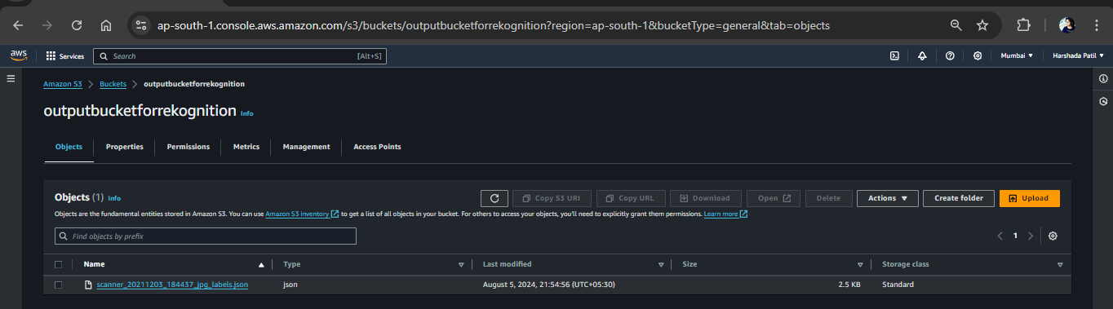

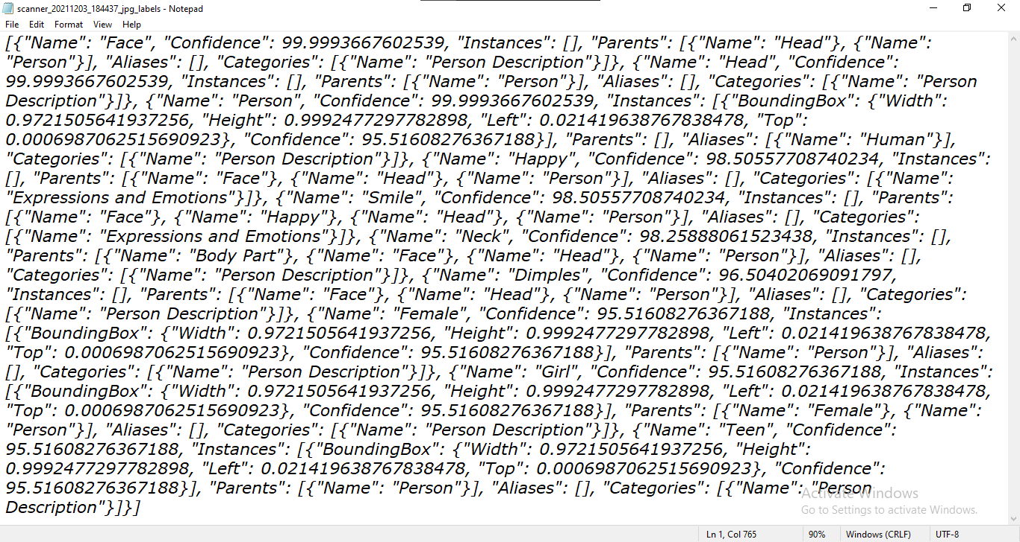



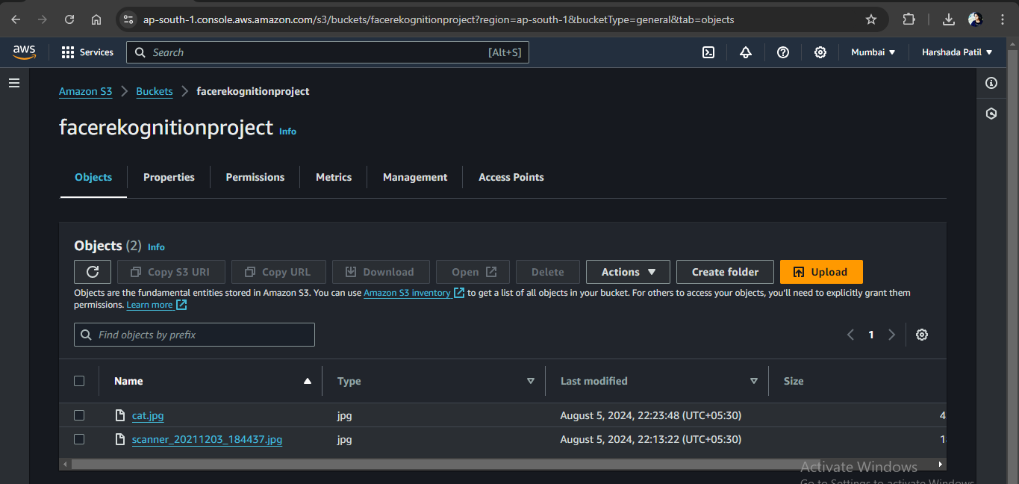

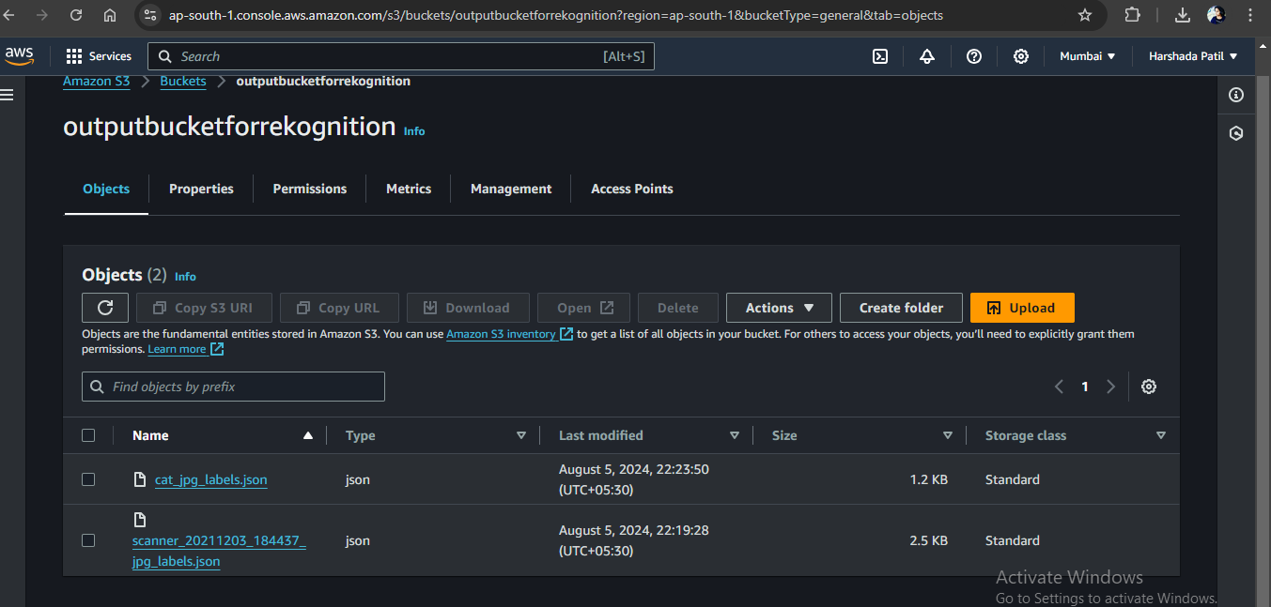

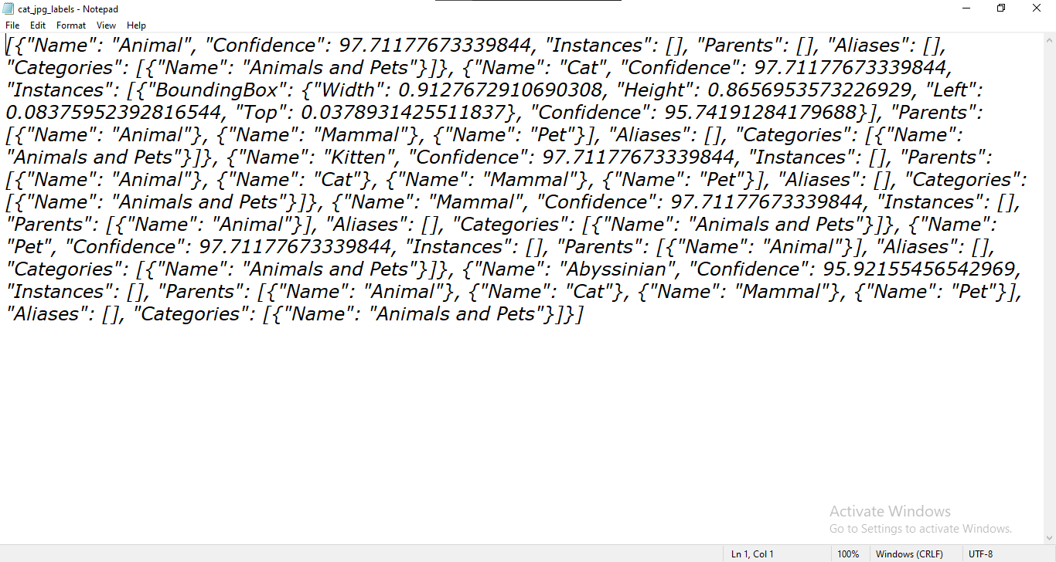

By following these steps, you should be able to set up and test your image processing application using AWS Rekognition with Python 3.12 in Lambda